**LAB 9: Flip Flops (JK, D, T)**

**Question 1: Write a Verilog code to implement J-K flip flop and validate the code via a suitable Test bench code.**

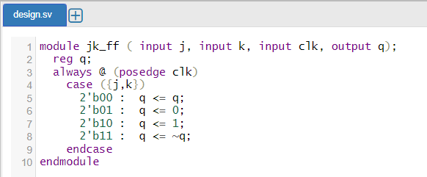

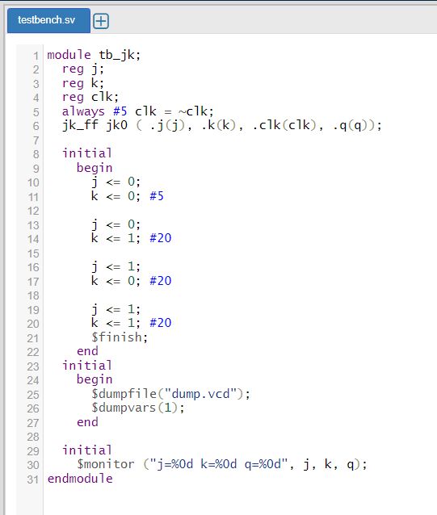



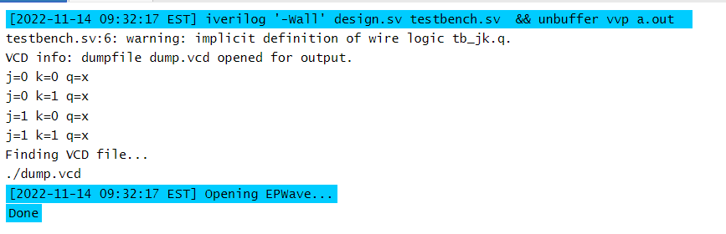

**Question 2: Design a J-K flip flop in Logisim and validate the circuit.**

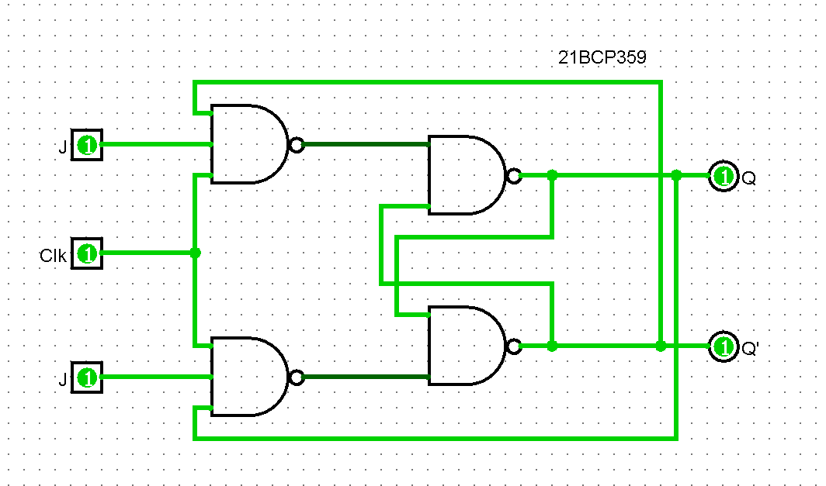

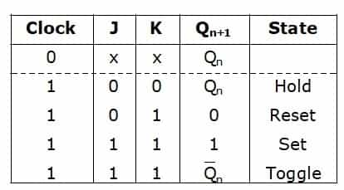

**Question 3: Write a Verilog code to implement D flip flop and validate the code via a suitable Test bench code.**

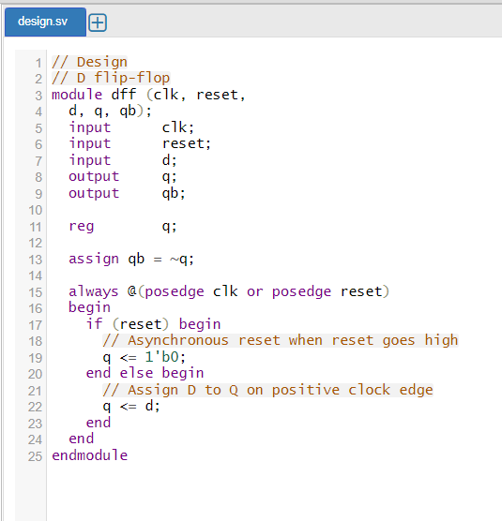

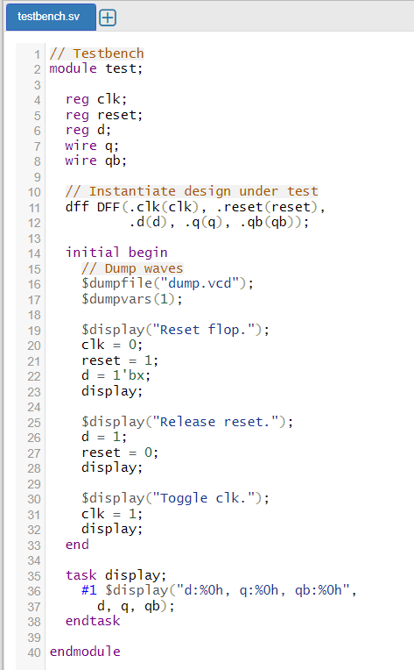



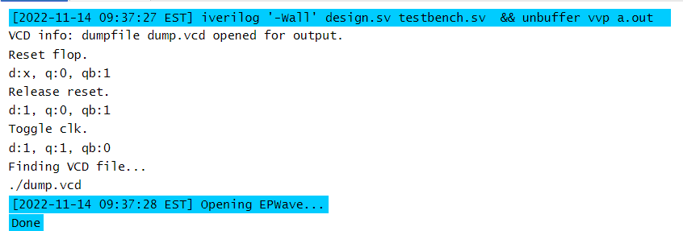

**Question 4: Design a D flip flop in Logisim and validate the circuit.**

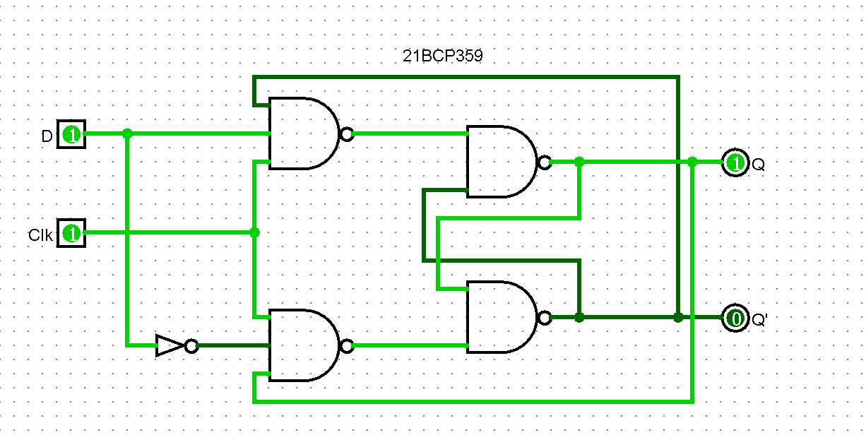

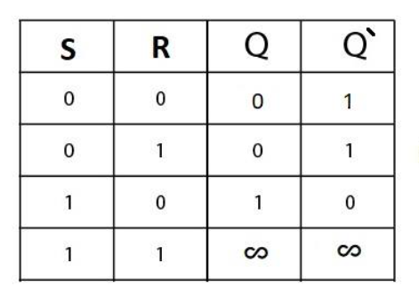

**Question 5: Write a Verilog code to implement T flip flop and validate the code via a suitable Test bench code.**

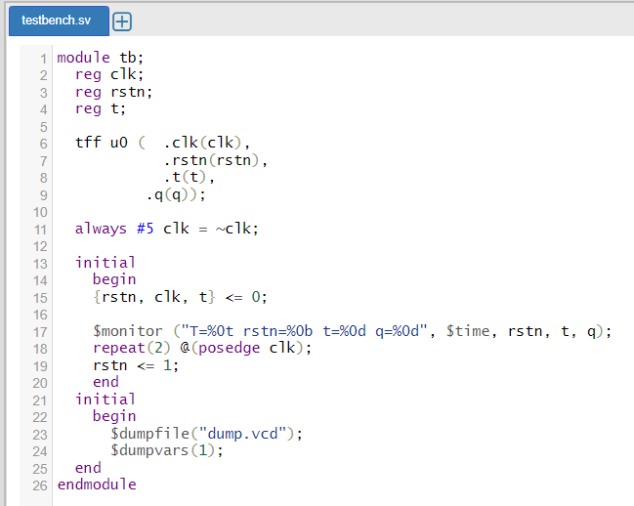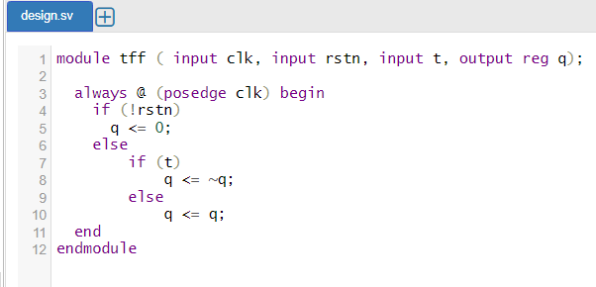

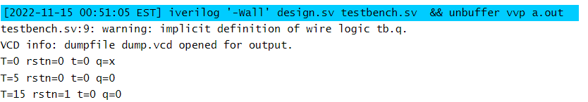

**Question 6: Design a T flip flop in Logisim and validate the circuit.**

